******* Jenkins integration with Docker ******

******* create pipeline to build docker image using jenkins and push the same on docker hub ******

step1: create instance and install docker

* goto your amazon console account and create 1 instance

AMI: ubantu OS

chnage volume size: 30

in security groups add all tcp and http

before launching the instance download the pem file

using that we can connect to mobaXterm

* start mobaXterm

move to that location where you have stored .pem file

execute ssh command provided on ssh client

* install docker on instance

1. set up the repo

> sudo apt-get update

> sudo apt-get install ca-certificates curl gnupg lsb-release

2. Add Docker’s official GPG key:

>curl -fsSL https://download.docker.com/linux/ubuntu/gpg | sudo gpg --dearmor -o /usr/share/keyrings/docker-archive-keyring.gpg

> echo "deb [arch=$(dpkg --print-architecture) signed-by=/usr/share/keyrings/docker-archive-keyring.gpg] https://download.docker.com/linux/ubuntu $(lsb_release -cs) stable" | sudo tee /etc/apt/sources.list.d/docker.list /dev/null

3. Install Docker

> sudo apt-get update

> sudo apt-get install docker-ce docker-ce-cli containerd.io

it will prompt do you want to continue type Y

* if docker installed chek versions

docker -v or docker --version

sudo docker info

**step 2: install jdk**

> sudo apt-get update

>sudo apt install default-jdk -y

**step 3: install maven**

> sudo apt-get update

**>sudo apt install maven -y**

step 4: install jenkins

>curl -fsSL https://pkg.jenkins.io/debian-stable/jenkins.io.key | sudo tee /usr/share/keyrings/jenkins-keyring.asc > /dev/null

>echo deb [signed-by=/usr/share/keyrings/jenkins-keyring.asc] https://pkg.jenkins.io/debian-stable binary/ | sudo tee /etc/apt/sources.list.d/jenkins.list > /dev/null

>sudo apt-get update

>sudo apt-get install jenkins

It will prompt > type y to install

********start Jenkins service ***********

>sudo service jenkins start

>sudo service Jenkins status

From the startus you can copy the password if not then

> sudo cat /var/lib/jenkins/secrets/initialAdminPassword-- 62b996dd344d429ea76c680fbcb26f9a

Copy the password and open yourPublicIp:8080

Enter initial password + install suggested plugins + set up your account and start Jenkins (--http://100.24.35.26:8080/)

Once you are in Jenkins dashboard then let’s install docker plugin

manageJenkins> managePlugins> available> search for Docker> install docker plugin without restart

Configure docker cloud in Jenkins

**manageJenkins**> manage nodes and clouds> configure cloud (left side)>

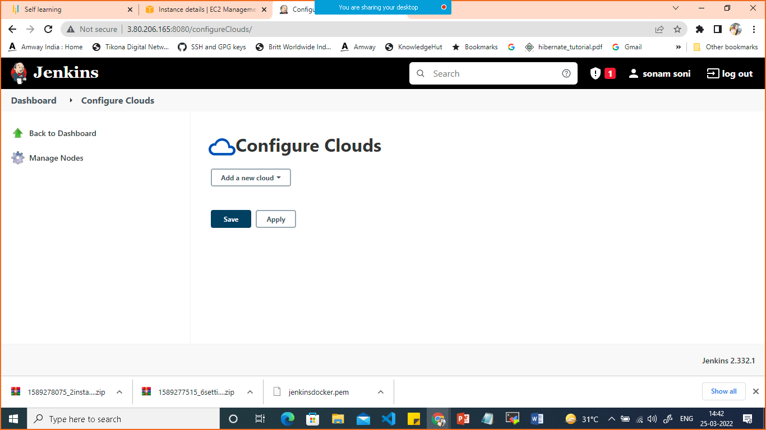

**Click on add a new cloud**

**Select docker from the dropdown**

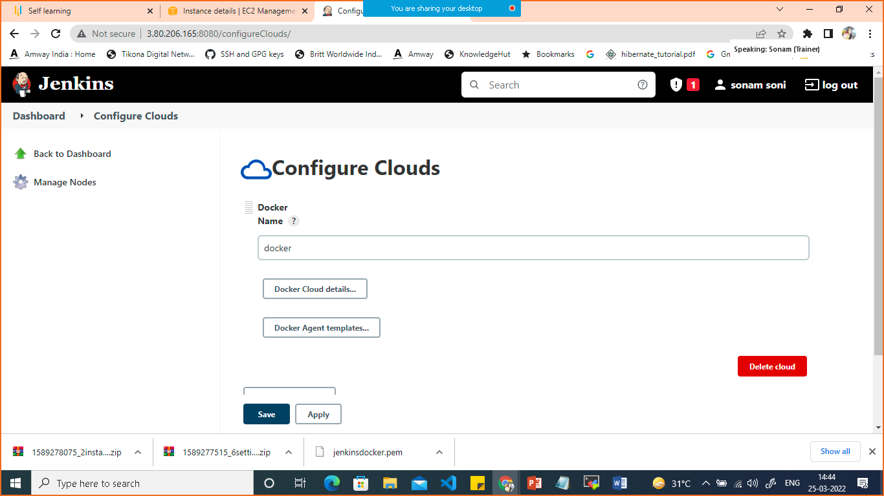

**Click on docker cloud details**

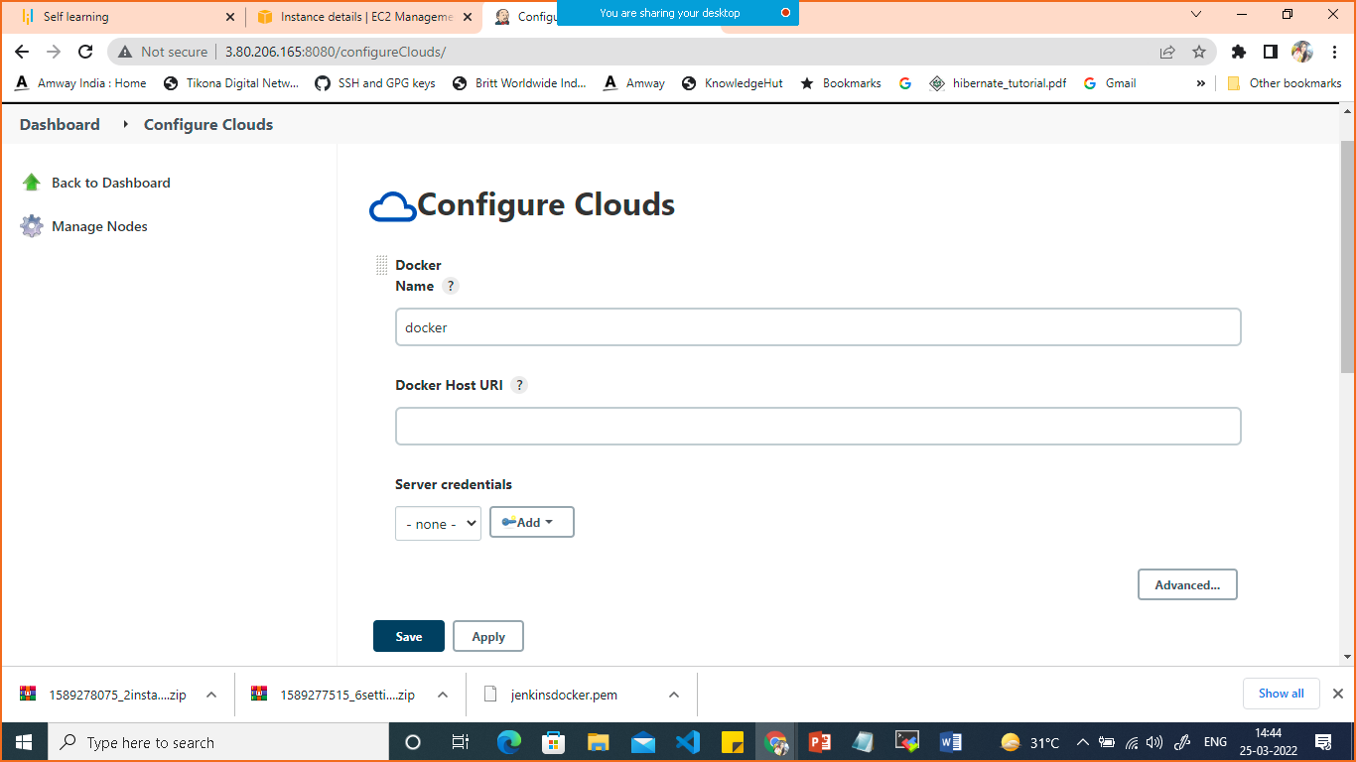

**Keep name docker only**

**Add Host URI: unix:///var/run/docker.sock**

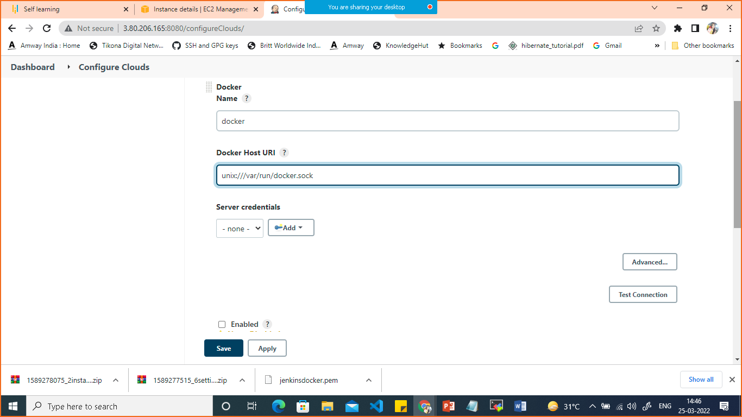

Click on test connection and check getting error of permission denied then execute this command on your console

sudo chmod 777 /var/run/docker.sock

you can open configure cloud again and check the connection it will show you docker version

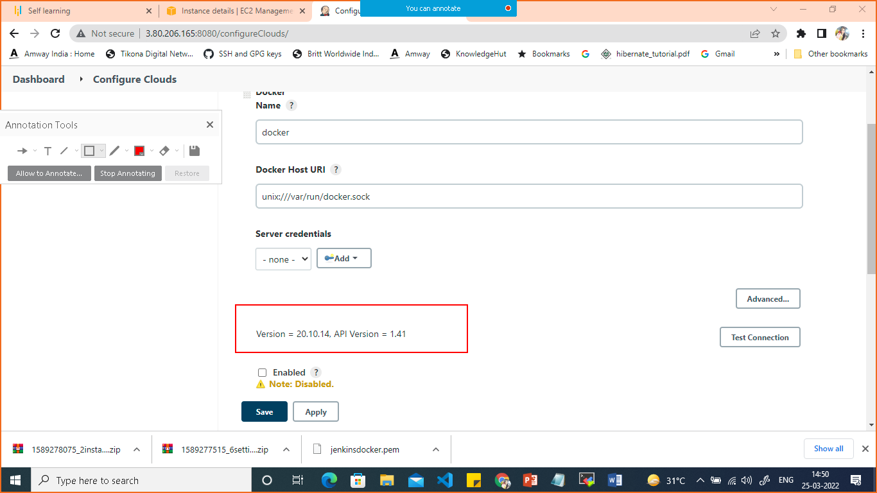

Let’s create a freestyle project(job)

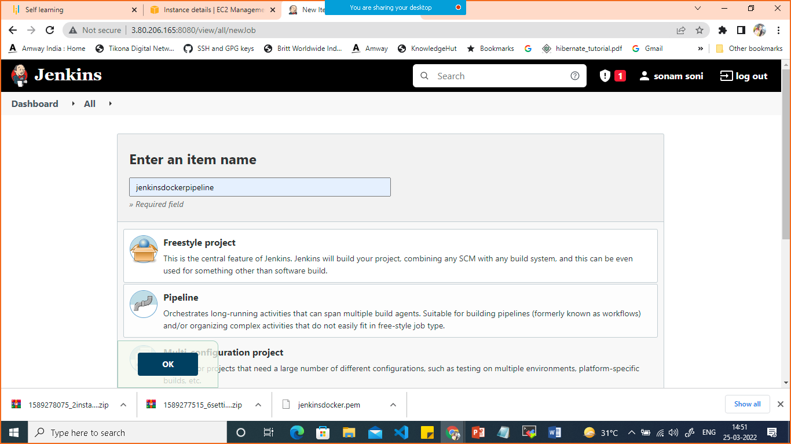

Configure project

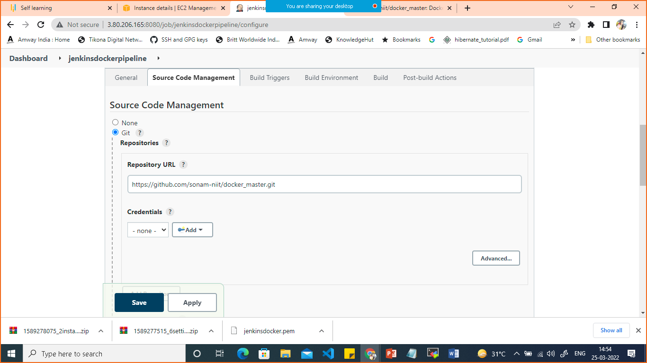

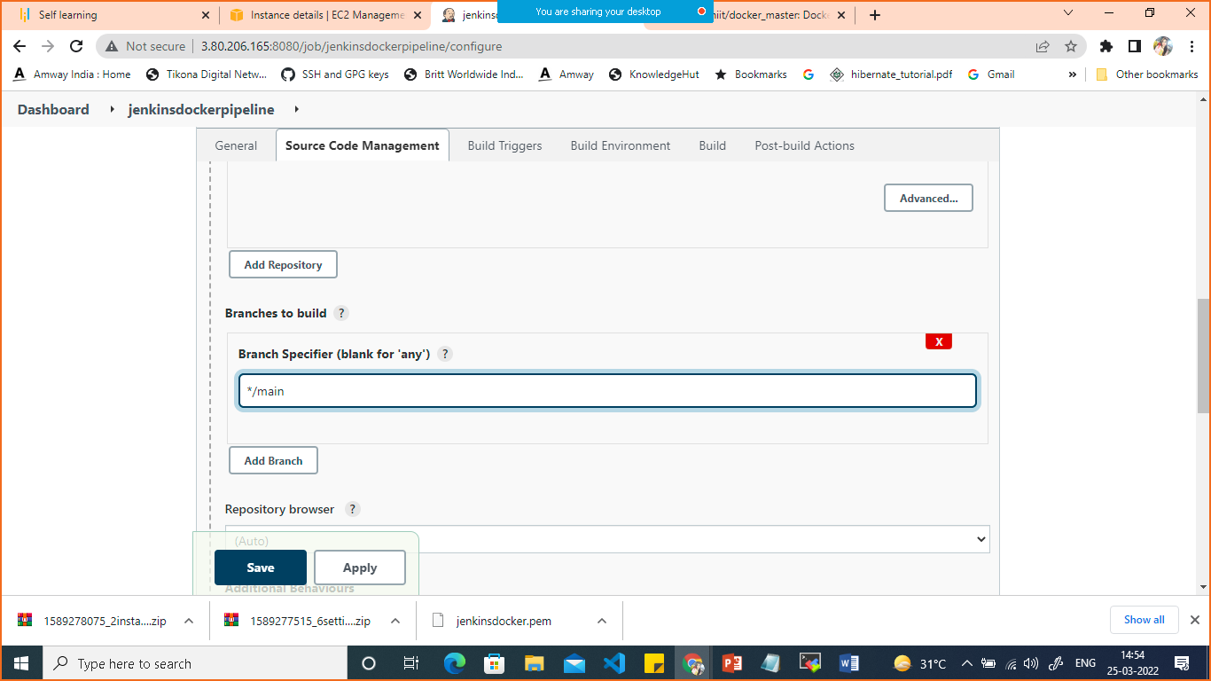

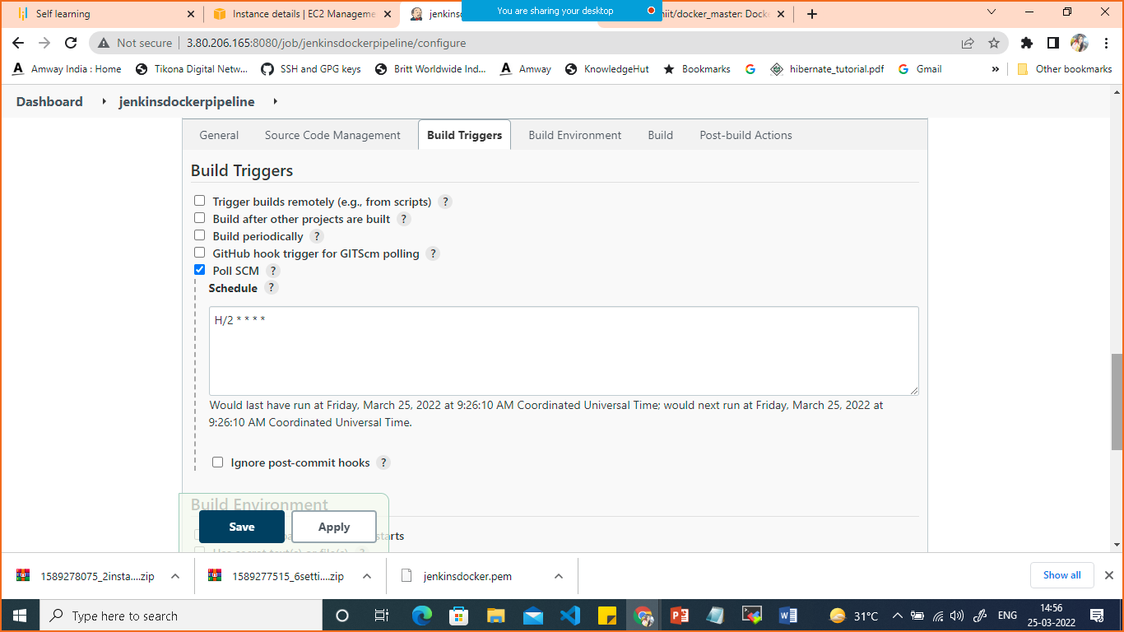

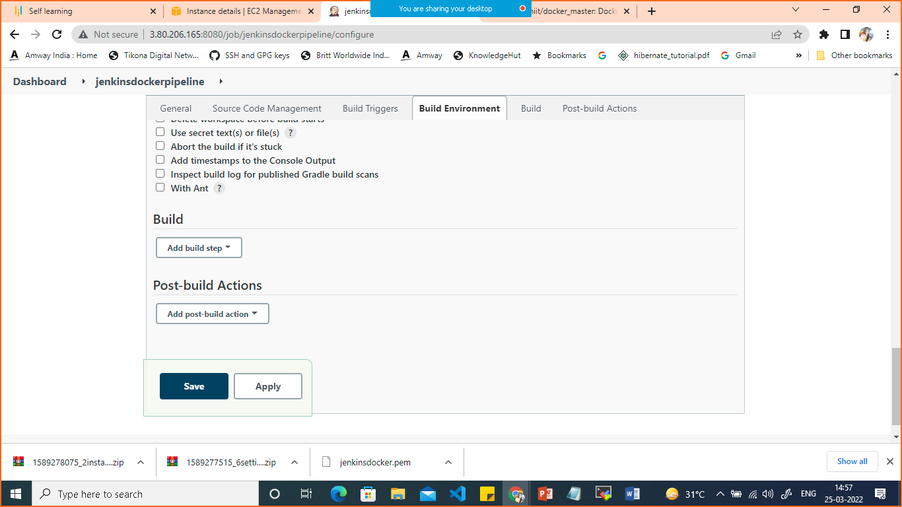

Click on add build step

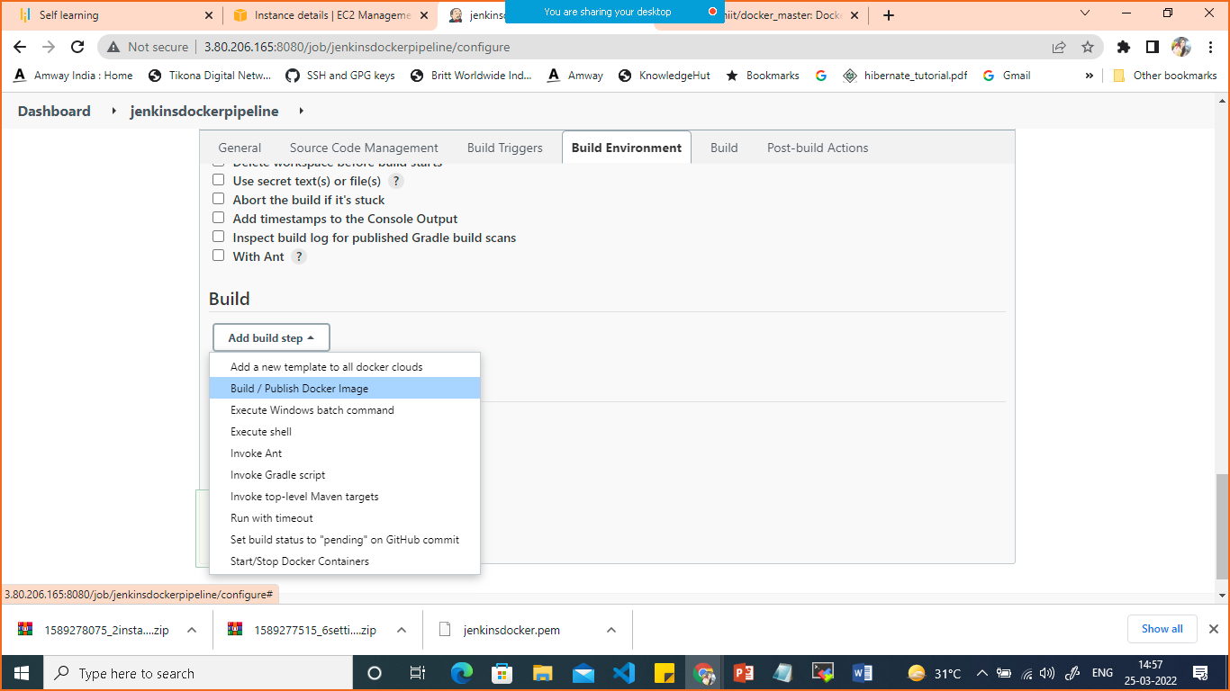

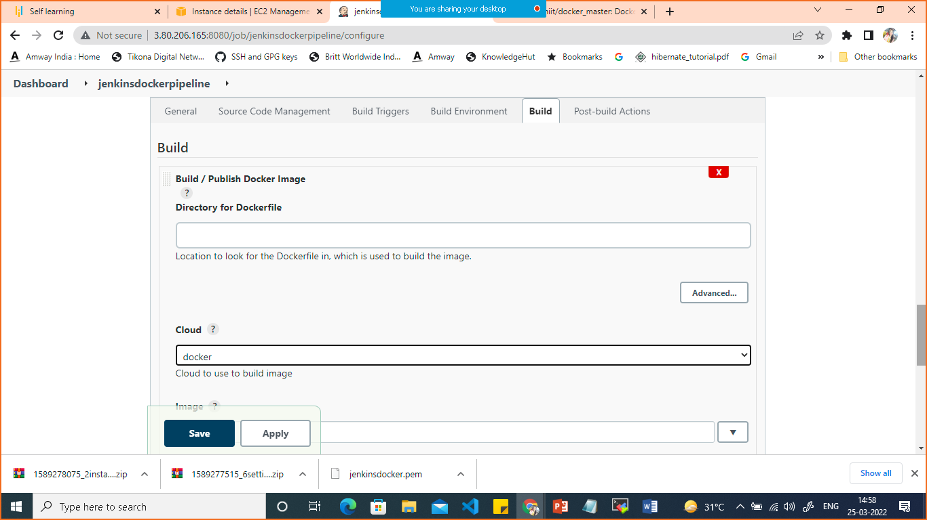

As docker file inside the root folder the directory of dockerfile kept empty

In cloud select docker

Add image name, add docker hub credentials

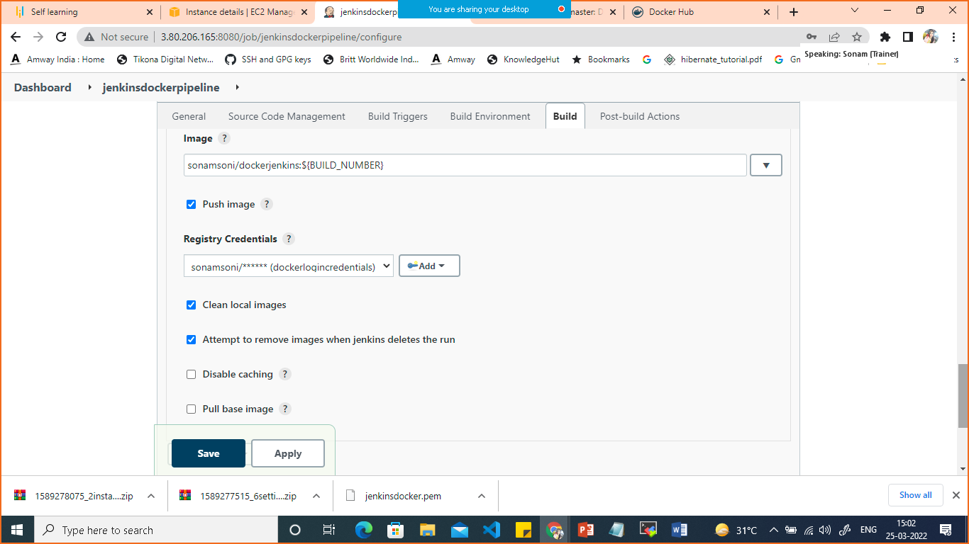

Click on save and build now.

Later on you can change your git hub repo

It will take build automatically

<http://100.24.35.26:8080/job/jenkinsdockerpipeline/>

Version = 20.10.14, API Version = 1.41